Jerry W. Schrecker
1002 Asbury Rd
Eastover, North Carolina, 28312
Bureau of Consumer Protection
Federal Trade Commission
600 Pennsylvania Ave., NW
Washington, DC 20580

May 31, 2024

RE: Complaint Against Charter Communications DBA: Spectrum

Complaint Evaluation Questionnaire;

- Is this complaint solely about buyer's remorse (you regret spending money on the product or service)?
- Is your complaint based solely on a price that was higher than prices charged by others?
- Are you solely seeking an apology from the business?
- Are you filing this complaint for information only?
- Is your complaint solely about discrimination or civil rights violations?
- Is this an employee/employer complaint?
- Is this a landlord/tenant complaint?
- Does your complaint seek a criminal penalty?
- Are you a business attempting to collect money from another business?
- Has this complaint been filed in court?
- Is the business you have a complaint with in Chapter 7 bankruptcy?
- Is this complaint regarding a previously filed complaint?

- Answer is “no” at this time, to ALL of the above questions.
Dear Sir/Madam,
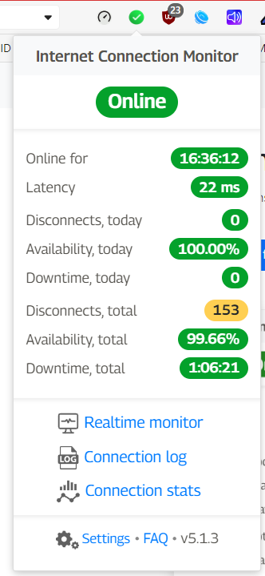
I am writing to file a complaint against Spectrum for the poor quality of internet service provided. I have encountered significant network issues while accessing numerous websites, which I believe are indicative of systemic problems within Spectrum's network infrastructure.
The internet service that has been received of late has become increasingly frustrating. I have experienced several disruptions throughout the day such as my computer stalling as I attempt to post a comment to Facebook or other social media. I would experience disruptions when viewing my emails. Any downloads were repeatedly disrupted. I know that it was not the fault of any of these individual programs or web sites because on each disruption all I had to do was simply hear the ICM warning sound and look at my browser toolbar and I’d see the Internet Connection Monitor (ICM) icon was a glaring red indicating that the internet connection was disconnected. I’m also experiencing significantly lower download speeds than what I’m paying to receive (1 Gb [1000 Mbps] Service).
Particular attention should be made to the fact that these issues with Spectrum’s service have been experienced by more subscribers than just me in the area of Tranquil Acres (Eastover, N.C.) as evidenced by the complaints stated by my next door neighbor, Ashley Lewis, 1004 Asbury Rd., Eastover, N.C. 28312, Meredith O’Briant, 1009 Jimree Ave., Eastover, N.C. 28312 and Linda Moore, 2555 Dunn Rd., Eastover, N.C. (see Appendix 1)
My next door neighbor, Ashley Lewis, commented to me that she had experienced numerous disruptions to several internet interviews that she conducts daily as a part of her job. Mrs. Lewis stated further that the disconnections had gotten worse over the past few months.
Another nearby neighbor, Meredith O’Briant, echoed the similar complaints regarding disconnections and Spectrum’s poor service.
This additional information shows that the same issues are affecting two or more subscribers on the same service leg. This is very indicative that it is the service itself that is at fault and not the individual subscribers’ equipment or wiring (see Appendix 2).

: https://nextdoor.com
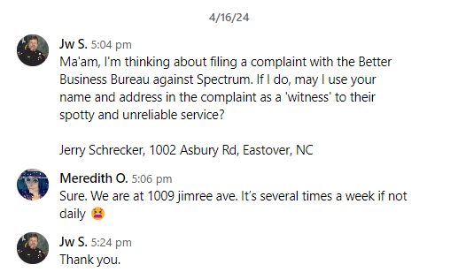




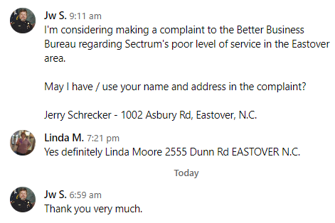

Documentation Process:
I utilized the following tools to document and evaluate the service that I’m receiving from Charter Communications DBA Spectrum. See the included flash drive for the following supporting files;
- 1002 Asbury Rd_Eastover_NC_Internet Disconnects_05152023-04142024.jpg
- Cable Modem Diagnostics_05262024-1022AM.odt
- ICM Charts Reflecting Data 05152023-04172024_subdata 03252024-04172024.jpg
- Internet Connection Monitor Log_05182023-04142024.ods
- Internet_connection_log_ICM04212024-05192024.csv
- jwschrecker-spectrum-04-23-2024 _ 05-30-2024---testmy.net-stats.csv
- Netgear CM1000 v2 Cable Modem Log_01042024-01262024.ods
- Netgear CM1000 v2 Cable Modem Log_04102024-04122024.ods
- Netgear CM1200 Cable Modem Log_05162024-.ods
- PingPlotter Data__04112024-04172024.ods
- USGS Cape Fear River_Grove St_Rainfall Data_01012024-05182024 .ods
- WU Grannis Field Rain Gauge_04012024-05182024.ods
- WU Middle Rd Rain Gauge_0012024-05182024.ods

ICM
From the ICM web site;
The extension monitors the Internet connection and reports 3 statuses:
- 🟢 Online: Internet connected
- 🟠 Connection issues or "No Internet connection. Wi-Fi/LAN OK": if Chrome itself cannot properly determine whether Internet connection is down while you're connected to LAN (Wi-Fi/Ethernet) - this status will popup. Most likely, your LAN (Wi-Fi/Ethernet) is connected, but there is no Internet connection behind it. In most cases, it is ISP/provider issue
- 🔴 Offline or "No Internet connection": Internet disconnected. LAN (Wi-Fi/Ethernet) may work or not, but Internet itself is unavailable
Precise connectivity test with configurable testing interval
- Latency measurement
- Detect when Internet doesn't work even with operating LAN connection (Wi-Fi or Ethernet)
- Shows Disconnects, availability and downtime stats
- Play sound when connection goes online or offline
- Events log with CSV and PDF export
- Realtime connectivity and latency monitoring
TestMy.Net
From the TestMy.net web site;
Some ISPs question the legitimacy of many Internet speed testing sites, as they should, most of them aren't very good. At TestMy.net we are obsessed about accuracy. We have over 27 years of experience testing the World's Internet. TestMy.net's servers are on a network that has direct peering with some of the biggest names in the Internet backbone.
With multi-homed connectivity and bandwidth from over 25 independent Tier 1 carriers including Comcast, Cox, Time Warner, Charter, Qwest, Google, Level 3, Internap, NTT America, Equinix & Telefónica to name a few. The network has a total capacity of over 2000 Gbps and our servers have multiple gigabit uplinks into that network. TestMy is always overstocked with bandwidth and can meet the needs of even the most demanding connections. Our servers are also configured and tested to maintain full quality of service for thousands of miles.
Internet providers like to eliminate any variables when testing, so they send users to internally hosted speed tests. This can help an ISP mask their shortcomings, namely with peering. Remember, your provider isn't only responsible for giving you access to their servers... you're paying for Internet service, not LAN.
Make sure that they don't fool you into believing the problem has to do with the websites you're visiting. TestMy.net has been a trusted free Internet resource since before your ISP ever even thought about making a speed test... possibly before they even existed. Furthermore, TestMy grades all connections based on the same criteria regardless of provider and we are not affiliated with any providers so our results are unbiased. TMN has no stake in the outcome of your speed test results. We work for the consumer not the ISPs.
Be cautious of any internal speed test that your ISP may refer you to. Your ISP's test may still be helpful in troubleshooting but in most cases these servers are on an internal network server and they WILL NOT give you real world results. Some other speed test sites also will lead you to believe that testing off a server close to you will help. It may help your connection appear faster but is that realistic?
Testing off a server that is next door does not give you a real world results, especially if the server is within your providers network. How could it? When you use the Internet how often are the servers right next to you or hosted by your ISP... rarely or never. Other speed tests rely heavily on donated servers. The idea behind TestMy.net is that we give our users a benchmark under controlled conditions. Using servers of known quality.
Many call center techs and Internet technicians already know and trust this service. But, if your ISP questions our results or they try to send you to their speed test you may want to question the reason why. They expect you to go out on the Internet, right? [emphasis added]
Our proprietary testing method uses HTML5 standard and is unlike any other speed test in existence. We have no need to make any adjustments to your results. When you test here the numbers returned are precise up to 0.0001 and are not doctored in any way. Unlike the vast majority of speed tests out there, TestMy calls it how it sees it!
PingPlotter
From the PingPlotter web site;
PingPlotter can be used to “see inside” a network to identify problems like congestion, packet loss, and even device unavailability with an easy to use interface to pinpoint issues quickly. PingPlotter can track latency and packet loss over time and can test connections with ICMP, UDP, and TCP packets.
Netgear CM1000 v2 Cable Modem Logs
The purpose of a cable modem's log is to provide a record of events and activities occurring within the modem's operation and about the ISP’s service. This log serves several important functions:
- Troubleshooting: Cable modem logs contain information about errors, warnings, and other events that occur during operation. These logs can be invaluable for diagnosing and troubleshooting connectivity issues, signal problems, or configuration errors.
- Network Maintenance: By analyzing the log data, network administrators can monitor the performance of cable modems, identify trends, and proactively address potential issues before they escalate. This helps ensure the smooth operation of the network and minimize downtime.
- Security Monitoring: Cable modem logs may also include security-related events such as unauthorized access attempts or firewall activity. Monitoring these logs helps detect and respond to security threats, protecting both the network and the devices connected to it.
- Performance Optimization: Analyzing the log data can provide insights into network performance, including signal strength, throughput, and latency. This information can be used to optimize network configuration and improve overall performance.
- Compliance and Auditing: In some cases, cable modem logs may be required for compliance with regulatory requirements or industry standards. Keeping detailed logs helps demonstrate adherence to these standards and facilitates auditing processes.
Overall, cable modem logs play a crucial role in maintaining and troubleshooting cable modem networks, ensuring reliable connectivity, security, and performance for users. The end user should never be deprived access to the cable modem event log.
Details of the Issue:
- Diagnostic History
  - Netgear CM1000 v2 Cable Modem Logs
    - Log 01/04/2024 - 01/26/2024
      - 15 Instances - Critical (3) Started Unicast Maintenance Ranging - No Response received - T3 time-out: This indicates that the cable modem initiated a unicast maintenance ranging request but did not receive a response from the CMTS within the expected time frame, resulting in a timeout (T3). This can be caused by various factors such as signal interference, signal degradation, or issues with the cable infrastructure.
      - 1 Instance - Notice (6) DS profile assignment change: This indicates a change in the downstream (DS) channel profile assignment. The DS profile defines the parameters for downstream communication. A change in the DS profile could be due to network optimization or configuration adjustments by the ISP.
      - 2 Instances - Error (4) Missing BP Configuration Setting TLV Type: 17.9; Missing BP Configuration Setting TLV Type: 17.8: These errors indicate missing configuration settings related to Baseline Privacy (BP) protocol. Baseline Privacy is used for securing communication between the cable modem and the CMTS. Missing configuration settings could be due to provisioning issues or misconfigurations in the network.
      - 1 Instance - Warning (5) DHCP WARNING - Non-critical field invalid in response: This warning indicates that the cable modem received a DHCP response with an invalid non-critical field. DHCP (Dynamic Host Configuration Protocol) is used for IP address allocation. An invalid field in the DHCP response could be due to misconfigurations or issues with the DHCP server.
      - 1 Instance - Critical (3) SYNC Timing Synchronization failure - Failed to acquire QAM/QPSK symbol timing: This indicates a failure to synchronize timing for signal modulation. QAM (Quadrature Amplitude Modulation) and QPSK (Quadrature Phase Shift Keying) are modulation techniques used in cable communication. Failure to synchronize timing could be due to signal impairments or synchronization issues.
Based on the log, the errors suggest issues with communication between the cable modem and the CMTS, including timing synchronization failures, ranging timeouts, and missing configuration settings. These issues could be caused by various factors under ISP control such as signal interference, network congestion, provisioning errors, or equipment malfunctions. Troubleshooting and resolving these issues require coordination with the internet service provider's technical support team to diagnose and address the underlying causes.
Cable Modem Termination System (CMTS) - A cable modem termination system is a piece of ISP equipment, typically located in a cable company's headend or hubsite, which is used to provide data services, such as cable Internet or Voice over IP, to cable subscribers.
    - Log 04/10/2024 – 04/12/2024
Based on the provided log data, there seem to be several critical errors and warnings related to a cable modem's synchronization and maintenance ranging process. Here's an analysis of the potential causes:
      - 11 Instances - Sync Timing Synchronization Failure: This error indicates a failure to acquire QAM/QPSK symbol timing, which is crucial for proper communication between the cable modem (CM) and the Cable Modem Termination System (CMTS). It may suggest issues with signal synchronization or timing discrepancies between the CM and CMTS.
      - 47 Instances - Unicast Maintenance Ranging Issues: The log shows multiple instances of "Started Unicast Maintenance Ranging - No Response received - T3 time-out" and "Unicast Maintenance Ranging attempted - No response - Retries exhausted." Unicast maintenance ranging is essential for establishing bidirectional communication between the CM and CMTS. The repeated failures suggest potential issues with upstream signal transmission or reception, such as signal degradation, noise interference, or improper CM configuration
      - 5 Instances - Dynamic Range Window Violation: These warnings indicate that the received power level exceeds the expected range. It could be caused by fluctuations in the signal power level, possibly due to upstream noise, signal distortion, or improper signal amplification settings.
      - 26 Instances - Missing BP Configuration Setting TLV Type: These errors suggest missing configuration settings related to the Baseline Privacy (BP) protocol. It could be due to misconfiguration or compatibility issues between the CM and CMTS.
      - 1 Instance - MDD Message Timeout: This warning indicates a timeout while waiting for a message from the Modular Data Device (MDD). It could suggest communication issues between the CM and MDD, possibly due to network congestion, device malfunction, or configuration errors.
      - 13 Instances - DS Profile Assignment Change: These notices indicate changes in the Downstream (DS) channel profile assignment. While not necessarily indicative of an issue, frequent changes could be related to network optimization or configuration updates.
Overall, the critical errors and warnings suggest potential issues with signal synchronization, upstream communication, signal power levels, and configuration settings. Further diagnostics by the ISP, including signal quality measurements, network analysis, and device configuration checks, would be necessary to pinpoint the exact cause of these issues and resolve them effectively.
  - Internet Connection Monitor (ICM) – I added the ICM extension to my browser May 15, 2023 and it was kept active until I reformatted my hard drive and reinstalled Windows 11 and my other programs on April 19, 2024 to see if there issues with my personal computer that was causing problems. There were not. The problems still persisted just as before.
    - The disruptions by month and day and average duration of internet disruptions by each month and year is as follows:
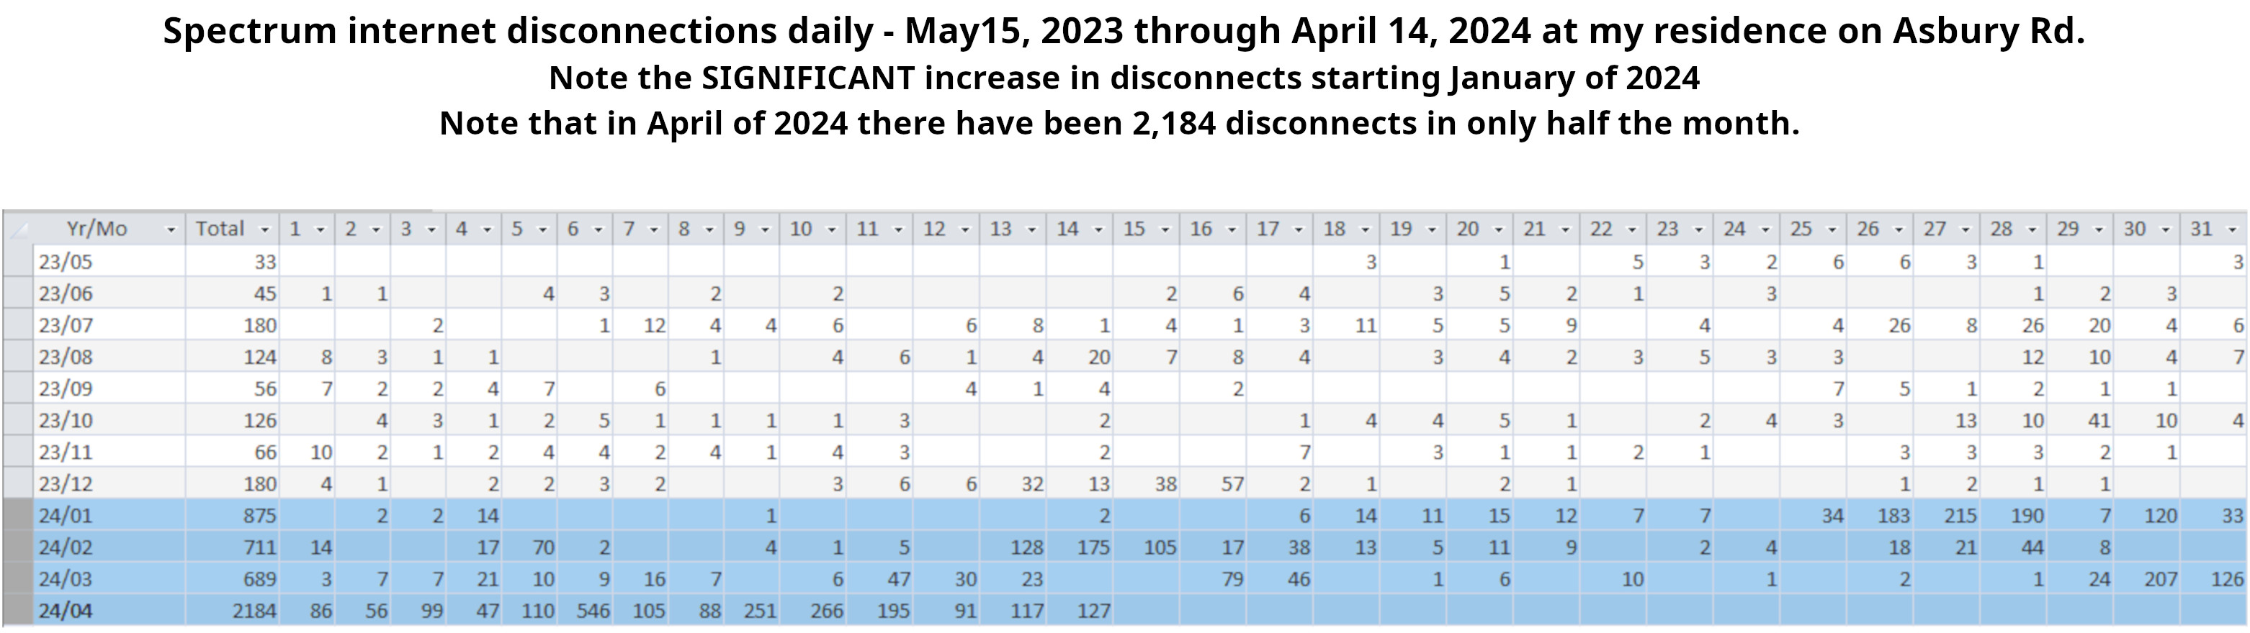
  - TestMy.Net
    - Upload Speed Analysis:
      - Average Upload Speed: 31.68 Mbps
      - Advertised ‘Typical’ Upload Speed: 35 Mbps

Download Speed Analysis:
      - Average Download Speed: 628.54 Mbps
      - Advertised ‘Typical’ Download Speed: 1000 Mbps

Conclusion:
      - Upload Speed: The average upload speed of 31.68 Mbps is slightly lower than the advertised speed of 35 Mbps. While the difference is not significant, it indicates that the upload speed may not fully meet the advertised value.
      - Download Speed: The average download speed of 628.54 Mbps is considerably lower than the advertised speed of 1000 Mbps (1 Gb). This suggests that the download speed does not meet the advertised service.
    - Overall UL/DL Assessment: - It appears that the service received does not fully meet the advertised speeds. While the upload speed is close to the advertised value, the download speed falls significantly short of the advertised 1 Gb service. This indicates that there may be limitations or issues with the network infrastructure or service provider affecting the actual speeds experienced by the user.
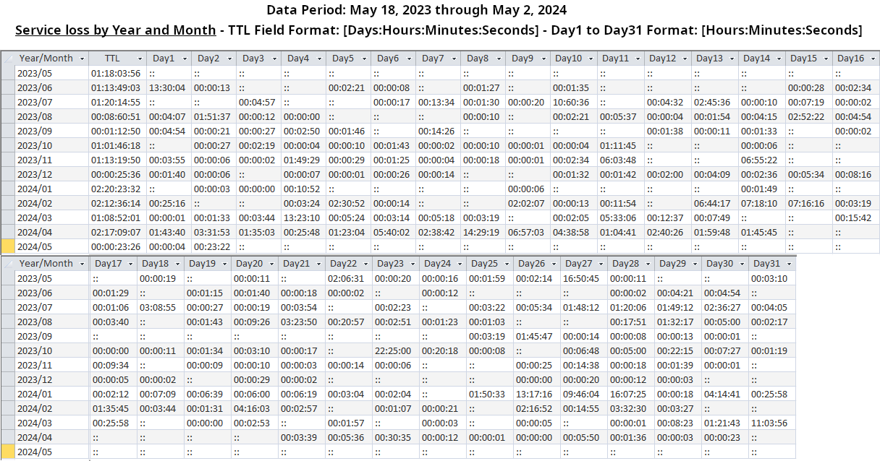
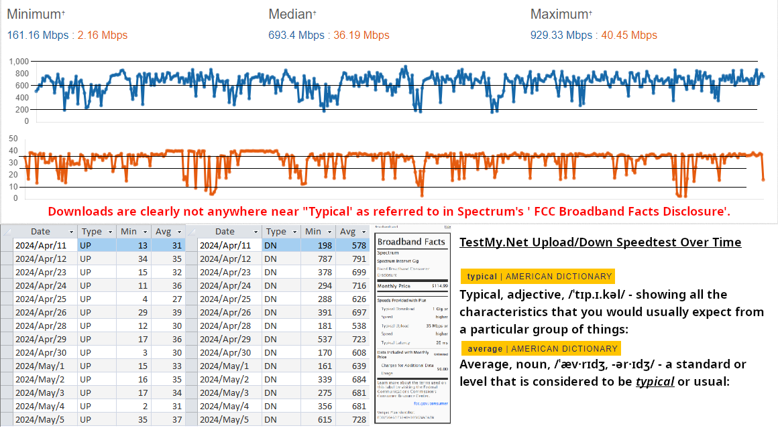
    - Time of Day Analysis:
      - Peak Usage Hours: There seems to be a consistent pattern of lower speeds during the evening hours, especially between 6:00 PM and 12:00 AM.
      - Consistency: Speed fluctuations are observed throughout the day, but the most significant drops occur during the evening hours.

Day of Week Analysis:
      - Weekend vs. Weekday: There is a noticeable difference in speeds between weekdays and weekends. Weekdays tend to have lower speeds, particularly during the evening hours, compared to weekends.
      - Consistency: The pattern of lower customer speeds during the evening hours is consistent across all days of the week.

Recognizable Patterns:
      - Provisioning Problems: The consistent pattern of lower speeds during peak evening hours suggests potential provisioning issues, especially if these patterns persist over multiple days.
      - Saturation Problems: The significant drops in speed during the evening hours, regardless of the day of the week, indicate possible network congestion or saturation problems during peak usage times.
    - Overall Provisioning/Saturation Assessment: - Based on these observations, it appears that there may be provisioning or saturation issues, especially during peak evening hours. Further investigation into network capacity and provisioning levels during these times would be advisable to address these issues and ensure consistent service quality.

  - PingPlotter - I recently conducted a network diagnostic using PingPlotter to assess the performance of my internet connection to www.akamai.com. The results revealed several concerning issues, which I have outlined below:
    - High Packet Loss - Hops 2, 4, and 6 showed high packet loss percentages of 71%, 54%, and 100% respectively. This severe packet loss indicates a significant problem with Spectrum's network infrastructure, causing disruptions in data transmission and affecting the overall quality of the internet service.
    - Elevated Latency: - The latency progressively increased from the second hop onwards, reaching a peak at the fifth hop before decreasing towards the target. This pattern suggests potential bottlenecks or congestion at certain hops along the route, adversely affecting the speed and reliability of the internet connection.
    - Saturated Pipe Issues: - The high packet loss and increased latency observed in hops 2, 4, and 6 indicate signs of a saturated pipe, further confirming the network congestion and inadequate bandwidth provided by Spectrum.
    - Supporting Analysis: - The detailed analysis based on common network problems and the resources from PingPlotter revealed the following:
      - Packet Loss: Can lead to slow data transmission, retransmissions, and application issues. The high packet loss percentages observed in several hops indicate network congestion, faulty hardware, or a failing router within Spectrum's network.
      - High Latency: Delays in data transmission affect application performance and user experience. The progressively increasing latency from the second hop onwards indicates potential bottlenecks, network congestion, or routing issues within Spectrum's network.
      - Saturated Pipe Issues: High packet loss and increased latency observed in several hops indicate signs of a saturated pipe due to inadequate bandwidth or network congestion. This issue needs immediate resolution to improve the overall performance and reliability of the internet service.
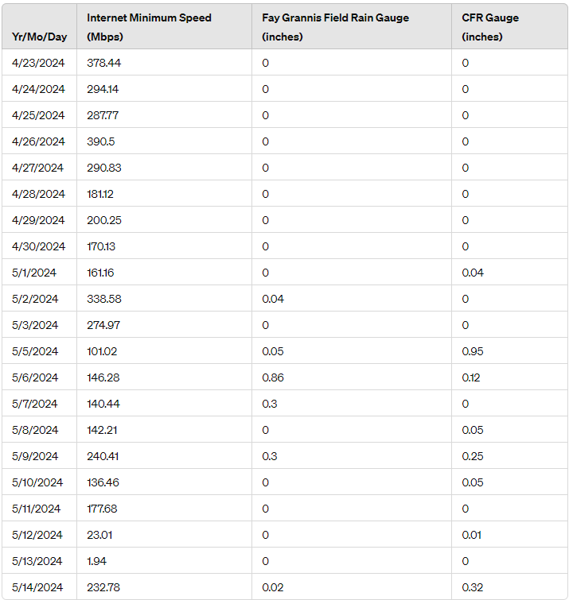
  - Weather Analysis - There is a significant correlation between rain events and the decline in internet speed provided by Charter Communications DBA Spectrum. The data collected over the past month clearly demonstrates a pattern of reduced internet speeds coinciding with the occurrence of rainfall.
Above is a detailed analysis of the data recorded from April 23, 2024, to May 14, 2024 [*CFR = Cape Fear River USGS Rain Gauge near Grove St. at Eastern Blvd, Fayetteville, N.C.]:
From the data, it is evident that internet speeds are substantially lower on days when rain is recorded. Notable instances include:
    - On May 1, 2024, internet speed dropped to 161.16 Mbps when 0.04 inches of rain was recorded at the CFR gauge.
    - On May 5, 2024, the internet speed plummeted to 101.02 Mbps with 0.05 inches at Fay Grannis Field and 0.95 inches at CFR gauge.
    - On May 6, 2024, internet speed was 146.28 Mbps with significant rainfall of 0.86 inches at Fay Grannis Field and 0.12 inches at CFR gauge.
    - On May 7, 2024, and May 9, 2024, internet speeds remained low at 140.44 Mbps and 240.41 Mbps respectively, with corresponding rainfall.

Conversely, on days without rain, such as April 23, 2024 (378.44 Mbps), April 26, 2024 (390.5 Mbps), and April 30, 2024 (170.13 Mbps), the internet speeds were notably higher.
The consistent pattern of reduced internet speeds during rainfall strongly suggests that the infrastructure or the service provided by Charter Communications DBA Spectrum is adversely affected by weather conditions. This issue is causing significant disruptions and impeding my ability to effectively use the internet service for which I am paying.
It is clearly Charter Communications DBA Spectrum’s responsibility to take corrective action to ensure reliable internet service regardless of weather conditions.
- Resolution History
  - Numerous calls were made to Spectrum to address these issues and correct them.
    - Sat 04/06/2024 from 11:00 AM-12:00 PM – A Field Technician came to my residence. He changed a couple of connectors. He used his meter and said that he detected noise on the line and claimed that it was my cable modem. The cable modem was a Netgear CM1000 v2 cable modem that is capable of supporting 1 Gbps (gigabit per second) internet speeds. I replaced my cable modem that day with a NETGEAR Nighthawk Cable Modem CM1200 that is capable of supporting a 1 Gbps internet connection (see Appendix 3). There was no change in my service and the issues persisted as before.
    - Mon 04/08/2024 from 1:00 PM-2:00 PM – This technician asked if the previous technician had done anything. I told him that the previous technician had changed a couple of connections and that was it. This technician changed the coaxial cable from the outside wall box, under the house and up the wall to the cable modem. I assisted him with this by feeding the cable through the wall to him. This technician also commented that there was noise on the line coming upstream from Spectrum too. There was no change in my service and the issues persisted as before.
    - Wed 04/10/2024 from 1:00 PM-2:00 PM (James) – This technician changed the coaxial cable from the outside wall box to the pole.
This technician also stated that he had noted that there was a damaged port on the ‘tap’ on the service pole, that he had reconnected me to another port on the tap. I commented that maybe the tap was the problem and that it should be replaced as that could explain why my neighbor (Ashley Lewis) was having the same problems I was with her Spectrum service.
This technician explained a ‘Field Technician’ can only work on the connection from the ‘tap’ located on the service (telephone) pole downstream to the residence. The Field Technician can’t work on the tap other than to connect to it. Everything from the tap upstream to Spectrum can only be worked on by the ‘Maintenance Team’.
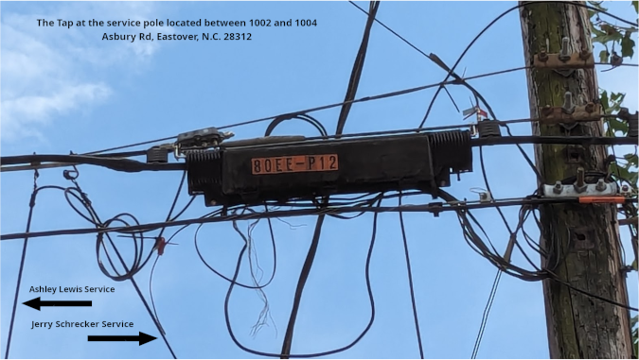
Afterwards he spent a lot of time on his meter connected to the point where it would have connected to the cable modem in my office. I noted the he had a confused look on his face and seemed to be displeased with the results he was getting. I suspected that he was experiencing the upstream ‘noise’ issues that were commented on by previous Spectrum Field Technicians. Since all cabling, and connectors to the pole was now new, installed by Spectrum, and my local area network (LAN) was excluded from his tests, any problems he was experiencing had to come from upstream from Spectrum.
The technician told me that he would come back into the house in a little bit but spent several minutes walking back and forth in my front yard on his cell phone. I noted that this technician seemed agitated and was waiving one arm around in quite obvious irritation over something while holding his cell phone to his ear with the other hand. When I walked outside to my front porch to enjoy my cup of coffee, the technician then walked out of my view to behind his van. Presumably so that I wouldn’t overhear his conversation.
After about a half hour of this the technician walked back to me and said if I had any more problems to call Spectrum back. He left. There was no change in my service and the issues persisted as before.
    - Mon 04/15/2024 from 11:00 AM-12:00 PM (Robert) – This technician acted very strangely. When he arrived, rather than come to the door, he sat in his van and called me. Said that he would be outside working on the problem. I got the impression that he was very anti-social.
I had constructed a document (see Appendix 4) that I thought would aid him in detecting where to start looking for the problem. As he was talking to me on the phone I simply walked up to the driver’s door of the van and waived at him. This technician started as if he had been scared and just looked at me with his mouth hung open.
I disconnected the call and waited for him to roll down the window. He seemed reluctant to do so, but he did. I gave him a copy of the document and explained it to him. He seemed reluctant to take it, but did.
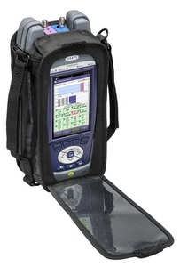
I watched him to see what he would do. He changed out the connections at the outside wall box again stating that they were improperly crimped and showed me a connection he had cut off citing that it was improperly seated. Having dealt with coaxial cable and connectors from the 70s regarding Citizen Band radios, through Cable television, satellite television and now internet connections and being familiar with such connections, I saw nothing wrong with the connection. This technician said in an arrogant bragging manner that he was the supervisor over the other technicians in my area and that was why he was sent to my home to double check that the other technicians before him had done their ‘due diligence’. The technician kept commenting on due diligence and how the meter he was using was his ‘protection’.
The technician made a big show of using his meter and droned on and on about how he didn’t see any noise in the line to the pole. He called me to his side and shaded his meter with his hand for me to see. I saw a solid line going across the meter.
I noted that the meter was a VIAVI spectrum analyzer, a commonplace device used in the cable industry.
It is a portable ‘computer’ that uses software to analyze Spectrum’s system, much like using ICM, TestMy.net, or PingPlotter on a personal computer. Only VIAVI is used for short duration system spot checks by Spectrum employees whereas ICM, TestMy.net, and PingPlotter are capable of prolonged continuous testing of internet systems.
When I asked him to connect his meter to the line going into the house and check it too he seemed reluctant but did so. I asked him about any noise on the line into the house and onward to my LAN. Since we were both looking at the meter he had to acknowledge that there was no noise on my end of the network either as the line was just as solid as before. It seems that his prestigious meter had suddenly become my protection.
I must admit that I grinned and said to him, “Gotcha”! The technician had previously removed something from the end of the coaxial cable (presumably some kind of RF coaxial termination dummy load or continuity device) and had reconnected it back to my cable modem (LAN). I was pleased to see that this Spectrum employee had verified that there was no ‘noise’ coming from ‘my’ lines or equipment.
This technician still seemed desperate to convince me that it was my brand new cable modem that was the problem and not Spectrum’s equipment, provisioning or saturation problems on their end.
I pointed out to him again that these problems were intermittent and that since I had a new cable modem, new Cat 6 Ethernet Cables and a new router (see Appendix 2) that it was very unlikely that my equipment was the issue.
I then told him that if he thought it was my new cable modem that was the problem then to put a Spectrum cable modem in its place and we’ll see if the problems persist. He replaced my new cable modem with a Spectrum cable modem.
I impressed on him that I was tired of all the excuses and that I simply wanted him to fix the problem so I could receive the service I was paying for. I told him that I know he didn’t design or build the system but that he was a representative of the company and that I expected him to go back and tell his supervisors that if these issues weren’t corrected soon that my next step would be a complaint to the Better Business Bureau.
He wasn’t very happy when he left. There was no change in my service other than I no longer had the capability to access the cable modem’s diagnostic page and see what errors are logged regarding Spectrum’s system. This is intentional on Spectrum’s part (see Appendix 9). The issues persisted as before.
    - Tue 04/23/2024 from 8:00 AM-9:00 AM – Spectrum sent, as they referred to themselves, Michael Perez, a Company Manager and a Field Technician Supervisor alleged to be the supervisor over all the other Field technicians in this area came to my residence.
It was not ‘Robert’ from the previous call who alleged himself to be “the supervisor over all the other Field technicians in this area.”
They were sent out to investigate my issues with Spectrum's internet service regarding numerous disconnections and slow speed on my supposedly 1 Gb service I pay for. My speed currently ranges between 1.94 Mbps and 952 Mbps with an average of 646 Mbps. This equates to my getting only 64.5% of the 1000 Mbps internet speed I’m paying for, an average of 35.5% of internet service paid for but not produced by Charter Communications DBA Spectrum.
Even had a Cumberland County Sheriff's Deputy stop by. I guess this was the most exciting thing going on in Eastover at the moment. He didn't have anything interesting to pass on and didn't stay long.
The manager and supervisor spent from 8:00 am to about 10:00 am checking my connection between the pole and my house to verify that there was nothing wrong with my connection.
Considering that it was Spectrum who replaced these lines in the past three weeks, including installing their own cable modem in place of my perfectly good brand new cable modem, I didn't expect that they'd find the problem there. They didn't.
I guess Perez, in consultation with the technician supervisor, and after a few cell phone calls, apparently decided that there was a larger problem. Perez admitted as much when just before leaving he informed me that they had detected issues that were affecting the whole neighborhood, and possibly a larger area.
Mr. Perez said he was referring these issues to the “Maintenance Team” which presumably is an escalation to a higher authority in Spectrum's service repair sub-organization. Perez mentioned the words 'node' and 'lines'. Perez indicated that I should see improvements anywhere between a week and a month depending on what further diagnostics of the “lines”, “node” and whatever upstream devices there are reveal.
Perez also stated that they will try to keep any disruptions of the current service to between 10:00 pm and 6:00 am as much as possible to not interfere with those who work from home on their computers.
    - Wed 04/24/2024 – 9:54 AM – My wife called me as she was leaving our residence on an errand to tell me that a Spectrum bucket truck was stopped in front of our residence. I went outside and saw that there was a Spectrum employee in the bucket at the top of the pole who had connected a meter to the lines. He wasn’t up there long and left. Shortly thereafter I received a notice from Spectrum via email telling me that the issues had been resolved and the repair ticket closed out. There was no change in my service and the issues persisted as before.
    - Mon 04/29 from 9:00 AM-10:00 AM – When I initially called this time the call taker had me connect my personal desktop computer directly to the Spectrum cable modem. She stated that if I was connected to my router - that was then connected to the cable modem - that I would receive only 70% of my upload/download speed.
I question this as my router is a Netgear Nighthawk AX6 AX5400 router that is capable of supporting a maximum theoretical speed of up to 5400 Mbps across its multiple wireless streams and Ethernet ports. This is well above the 1000 Mbps (1 Gbps) speed provided by Spectrum.
My personal computer contains the ASUS ROG STRIX B550-F GAMING motherboard that is equipped with a Realtek® 2.5Gb Ethernet LAN port. This means it is capable of speeds up to 2.5 Gbps, exceeding the 1 Gbps speed provided by Spectrum.
My personal computer connections are all ‘wired’ with Cat 6 Ethernet cables. All the data provided are from tests conducted over ‘wired’ connections. I do not use Wifi other than for my cell phone and my tablet.
It occurred to me that the call taker was just reading from some instructional card stack / computer program and had no real knowledge of the capabilities of modern routers, cable modems, or other related internet consumer equipment.
I almost have the process memorized;
      - Reboot the cable modem. This is the magical solution and it doesn’t matter if you’ve already rebooted the cable modem one to six times prior to calling them. They’re going to insist you do it again. I would also note that the rebooting of the modem has the effect of clearing the cable modem log of any entries that it may have contained information that would assist one in tracking down what’s causing the problem. Doesn’t it seem strange that they are so eager to delete this information right away?
      - Disconnect your cable modem from the router and plug it directly into the cable modem. No, it doesn’t matter that you need a router in the average household to provide service for the rest of your family. Nor does it matter that your router is capable of 5 times the speed that they’re providing. I suppose that Spectrum thinks your entitled to only one usable device at your end.
      - Well, it must be your equipment because the call taker can see ‘no problems at all’ from their end. You mean you can’t see the 47 Instances - Unicast Maintenance Ranging Issues in the cable modem log indicating signal degradation and noise interference on the coaxial cable upstream that I copied and saved from the cable modem error log BEFORE I rebooted it? Oh,...yes, I see that now, I’ll schedule a field technician to come to your house to see what the problem is. Why yes, I do copy the cable modem log before I reboot my cable modem. This was before they put their own cable modem in place.
The call taker went on to say that by connecting my personal computer directly to the cable modem that I should receive 99% of my 1 Gb service speed. I suppose that this is the explanation provided for them on their instructional card stack / computer program to give the customer when questioned. According to this call taker I should then be receiving a download speed of at least 990 Mbps ‘TYPICALLY’, as in “on average”.
Since I have very modern equipment I should be receiving this 990 Mbps speed from Spectrum through their cable modem, through my Netgear Nighthawk AX6 AX5400 router, through my ASUS ROG STRIX B550-F GAMING motherboard that is equipped with a Realtek® 2.5Gb Ethernet LAN port and into my personal computer.
Regardless, I complied with her request, connected the coax cable directly to my cable modem, and then conducted a speed test at her direction. My speed result was 307 Mbps, substantially lower (69.3% lower) than 1 Gb service that I pay for, substantially lower than the “Typical Download Speed 1 Gb or higher” that Charter Communications DBA Spectrum states in their “Broadband Facts” filed with the FCC (see Appendix 8). The call taker said that I need to have a Spectrum technician come to my residence to see what was causing the problem.
I asked the call taker to check the notes on my service, that technicians had been to my residence several times and had already replaced my new cable modem with a Spectrum cable modem and changed out all the coaxial cable from the cable modem to the service pole.
I asked her what else could a Field Technician do and wasn’t it time to escalate these problems on up the chain of responsibility. The call taker advised that there was nothing more that she could do, that I had to start all over with a Field Technician service call. She scheduled an appointment.
I received a call from Michael Perez (Spectrum Manager) who canceled the appointment with my agreement and stated that he had no idea why the Maintenance Team had deemed the issue resolved and that he was referring the issue to the Maintenance Team again. I agreed with Mr. Perez (It’s not my intent to cause the company to unnecessarily waste money.) and saw no need for a Field Technician to respond to my house simply to tell me that there was nothing they could do and that the issue has been referred again to the Maintenance Team (see Appendix 5).
<Michael Perez (Spectrum Manager)> “I agree. What my supervisor showed me from last nights readings are speeds that drop as low as 100 and the upload speed struggled to get to 11. We should have enough to information to point the maintenance techs in the right direction.”
NOTE: This information confirms that Charter Communications DBA Spectrum knew, or reasonably should have known, that I’ve been receiving “up to” a 90% loss of 1 Gb Downstream service and a 68.57% loss of 35Mbps Upstream service that I’ve been purchasing from Charter Communications DBA Spectrum.
    - Tue 04/30/2024 – 4:00 PM – 5:00 PM – my neighbor, Ashley Lewis, said that she had called Spectrum.
<Ashley Lewis> “Not sure if your internet has gone out as well in the last 10 minutes or so. But I spoke too soon this morning. About an hour after I said I've not had many problems, I was at around 190mbps and struggling with those speeds for work. Spectrum is coming out for me today between 4pm-5pm. Once I got connected again my speeds were really slow.”
    - Tue 04/30/2024 – 5:03 PM – This is what I messaged to Mr. Perez;
Your guy in the bucket truck showed up @ 4:00 pm and for about 20 minutes stood in his bucket at the top of the pole and looked at his meter. A Spectrum employee in a van rolled up and the first thing he asked of bucket truck man was, "Is there an outage"? Bucket truck man said he conducted ten (10) tests in a row and only three (3) showed anything slightly wrong. He seemed to be dismissive of the three (3) errant tests.
He said something about how he had to go to Lumberton, N.C. and get a SPECIAL meter that would conduct some test that he wasn't able to do last week when he was at this pole testing. I immediately wondered how in the world he could have decided last week that there was no problem if he couldn't have performed a necessary test (obviously it was necessary, or he wouldn't have had to go to Lumberton today)?
He droned on to me with a couple of anecdotes about how he doesn't do Spectrum cell phone work and how Fayetteville's meters (spectrum analyzers) needed to be patched with some software update.
I told him a little of the history about the internet problems in this area to get him back on track. I then told him that he should get with you (I gave him your name.) and get the documentation from you about;
"What my supervisor showed me from last nights readings are speeds that drop as low as 100 and the upload speed struggled to get to 11. We should have enough to information to point the maintenance techs in the right direction."
Bucket truck man kind of hemmed and hawed and said that you were a "them" and he was some kind of different "us" with some kind of connections to Verizon because of sharing a backbone with them. He said that he would "try" to get that information if he could, but that his side really doesn't have anything to do with that side.
I then commented that all the evidence so far points upstream to the lines, node, and possibly even further upstream. He quickly retorted that he had already tested the node first with ONE test and found no problem there. As I stood there just looking at him, he suddenly spurted out while tapping his wrist watch, "Well, I only did one test at the node because of the time and I needed to get here." Does that make any sense to you? It didn't to me.
Also, I get the impression that these maintenance crews have no comprehension at all about "testing over time" vs. "immediate short spot checks". We'll never get to the bottom of what the problem is if they don't get a grasp of what true system diagnosis is.
I'm just not getting the impression that you're being taken very seriously, sir. I really wish you all could work together and resolve this issue. My neighbors and I should be getting what we pay for.
    - Thu May 2, 2024 – 9:11 AM – I received a phone call from Michael Perez regarding my text message to him Thu May 2, 2024 – 9:03 AM (see Appendix 7). Perez stated that the message I had received was due to another issue that had cause an outage and was unrelated to my issues.
    - Sat May 4, 2024 – 2:29 PM – I text messaged Michael Perez with an update reflecting that I had not seen any improvement yet in my service accompanied by a graph I prepared documenting my internet speed results for his review (see Appendix 7).
    - Tue May 7, 2024 – 11:47 AM – I text messaged Michael Perez with an update reflecting that it didn’t appear that his Maintenance Team had found the problem yet that was negatively my and other Tranquil Acres (Eastover) subscribers accompanied by a graph I prepared documenting my internet speed results for his review. I additionally requested an update from him regarding the issues. I received no reply (see Appendix 7).
    - Fri May 10, 2024 – 11:05 AM - I text messaged Michael Perez with an update reflecting that I still wasn’t receiving the internet speed I was paying for (1 Gb) (see Appendix 6) accompanied by a graph I prepared documenting my internet speed results for his review. The graph documented that the internet speeds I was receiving was substantially less than the speed of “1 Gb or higher” as stated in their “Broadband Facts” disclosure that Spectrum had filed with the FCC. I additionally requested an update from him regarding the issues. I received no reply (see Appendix 7).
    - Mon May 13, 2024 – 3:48 PM - I text messaged Michael Perez with an update reflecting that I had been experiencing significant degradation in my internet service as evidenced by a graph I prepared documenting my internet speed results for his review for that time period. The graph documented that the internet speeds I was receiving was substantially less than the speed of “typically 1 Gb or higher” as stated in their “Broadband Facts” disclosure that Spectrum had filed with the FCC. I additionally requested an update from him regarding the issues. I reminded that I had asked him twice previously for an update on the issues that I and my neighbors were experiencing and that I had received no reply (see Appendix 7). I asked him to at least have the decency to notify me that he was no longer responding to me, if that was the case (see Appendix 7). As of May 30, 2024 I received no reply from Michael Perez.
    - Thu May 16, 2024 – 9:31 AM – Having seen no improvements or any other differences other than the loss of access to diagnostic information with Spectrum’s cable modem I disconnected it and reconnected my NETGEAR Nighthawk Cable Modem CM1200 capable of supporting a 1 Gbps internet connection. As I suspected there are still several errors present indicative of signal interference, signal degradation, or issues with the cable infrastructure.
      - Summary of Log Entries (see flash drive file: Netgear CM1200 Cable Modem Log_05162024-.ods)
        - Unicast Ranging Received Abort Response: Several entries indicate that unicast ranging is not completing successfully.
        - No Ranging Response received: This message appears frequently, indicating a failure to receive responses from the upstream.
        - Sync Timing Synchronization failure - Failed to acquire QAM/QPSK symbol timing: Indicates issues with maintaining a stable connection.
        - No Maintenance Broadcasts for Ranging opportunities received: Suggests issues with the regular maintenance signals.
        - T3 Time-out: A common error indicating the modem did not receive a response to its request from the CMTS (Cable Modem Termination System) within the specified time.
        - T4 Time-out: Similar to T3, but more severe, indicating a complete loss of communication with the CMTS.
        - MDD message timeout: Indicates missing MAC Domain Descriptor messages, which are crucial for maintaining connection parameters.
      - Detailed Report
        - Unicast Ranging Received Abort Response - Re-initializing MAC
          - Occurrences: Multiple
          - Description: The cable modem tried to communicate with the upstream but received an abort response.
          - Probable Causes:
            - Upstream Noise: Excessive noise on the upstream path can cause the modem to abort ranging.
            - Upstream Power Level: If the upstream power level is too high or too low, it can cause issues.
            - CMTS Issues: Problems at the CMTS end can lead to aborted responses.

        - No Ranging Response received
          - Occurrences: Multiple
          - Description: The modem did not receive a response to its ranging request.
          - Probable Causes:
            - Signal Interference: Physical obstructions or electronic interference can block signals.
            - Line Quality: Poor quality or damaged cables can result in lost signals.
            - CMTS Overload: If the CMTS is overloaded, it may not respond to all requests.

        - SYNC Timing Synchronization failure - Failed to acquire QAM/QPSK symbol timing
          - Occurrences: Multiple
          - Description: The modem failed to synchronize with the network’s timing.
          - Probable Causes:
            - Signal Quality: Issues with the signal quality, such as noise or weak signals.
            - Hardware Issues: Faulty modem hardware can cause synchronization problems.
            - Network Configuration: Incorrect network configuration settings.

        - No Maintenance Broadcasts for Ranging opportunities received
          - Occurrences: Multiple
          - Description: The modem is not receiving necessary maintenance signals.
          - Probable Causes:
            - CMTS Configuration: The CMTS may not be properly configured to send maintenance broadcasts.
            - Interference: Physical or electronic interference preventing the signals from being received.

        - T3 Time-out
          - Occurrences: Multiple
          - Description: The modem sent three ranging requests but did not receive any response.
          - Probable Causes:
            - CMTS Issues: The CMTS may be malfunctioning or overloaded.
            - Signal Interference: High levels of interference or noise.
            - Modem Issues: Potential problems with the modem itself.

        - T4 Time-out
          - Occurrences: Multiple
          - Description: The modem sent four ranging requests but did not receive any response, leading to a reset.
          - Probable Causes:
            - Severe CMTS Issues: Complete failure to communicate with the CMTS.
            - Severe Signal Issues: Major issues with signal quality or interference.
            - Network Outages: Potential outages in the network infrastructure.

        - MDD message timeout
          - Occurrences: Multiple
          - Description: The modem did not receive necessary MAC Domain Descriptor messages.
          - Probable Causes:
            - CMTS Configuration: The CMTS may not be sending these messages correctly.
            - Network Issues: General network instability or configuration problems.

        - Conclusion
The log entries point towards a combination of signal quality issues, potential ISP hardware malfunctions, and possible configuration problems at the CMTS end. A thorough check of the ISP physical connections, signal quality, and communication with the ISP should help identify and resolve the persistent issues.
      - Netgear CM 1200 Cable Modem Diagnostics Web Page (see Appendix 11)
        - Downstream Bonded Channels:
          - Correctables and Uncorrectables: The correctable and uncorrectable codewords are high across all channels. High values indicate potential issues with signal quality or interference.
            - Correctables: Range from 59813 to 573125 across channels, indicating a significant number of errors being corrected.
            - Uncorrectables: Range from 48 to 3500, which is concerning as these are errors that could not be corrected and can impact connection quality.

          - Specific Channels with Notable Errors:
            - Channel 1: 1004504 correctables, 168 uncorrectables.
            - Channel 10: 88644 correctables, 68 uncorrectables.
            - Channel 14: 345407 correctables, 69 uncorrectables.
            - Channel 16: 465207 correctables, 112 uncorrectables.
            - Channel 21: 1949456 correctables, 3500 uncorrectables.
            - Channel 30: 1058274 correctables, 150 uncorrectables.

        - Upstream Bonded Channels:
          - Channel Lock Status: Channels 5, 6, 7, and 8 are not locked, which can cause upstream connectivity issues.
          - Power Levels:
            - Channels 1 to 4 have power levels ranging from 39 dBmV to 41.7 dBmV, which are within acceptable limits but should be monitored to ensure stability.

        - Downstream OFDM Channels:
          - Channel 1:
            - Correctable Codewords: Extremely high at 11895289909.
            - Uncorrectable Codewords: Also extremely high at 245250665.
            - These values indicate significant interference or noise on this channel.
          - Channel 2: Not locked, which could indicate potential configuration issues or hardware problems.

        - Upstream OFDMA Channels:
          - Both channels are not locked: This can contribute to poor upstream performance and indicates potential issues with upstream OFDMA channel configuration or signal quality.
        - General Observations:
          - Power Levels: Downstream power levels range from 2.8 dBmV to 5.3 dBmV, which are within the acceptable range but should ideally be closer to 0 dBmV for optimal performance.
          - Signal-to-Noise Ratio (SNR): SNR values for downstream channels range from 41.5 to 42.8 dB, which is good. However, the high error rates suggest other factors affecting signal quality.
          - IP Provisioning Mode: The modem is set to IPv6 only.

        - Recommendations:
          - Investigate High Error Rates: The high number of correctable and uncorrectable codewords indicates potential signal quality issues. This could be due to:
            - Poor ISP cabling or connectors.
            - External interference or noise.
            - Problems with the ISP's infrastructure.
          - Resolve Upstream Channel Lock Issues: Ensure that all upstream channels are locked for stable connectivity. This may involve:
            - The ISP needs to ensure there are no network configuration issues or hardware faults.
          - Monitor and Optimize Power Levels: While currently within acceptable ranges, maintaining power levels closer to 0 dBmV for downstream channels can help improve stability.
          - Check Compatibility and Settings: Verify that all network devices support IPv6, or consider enabling dual-stack (IPv4 and IPv6) provisioning if supported by your ISP and modem.
          - Given the high error rates and issues with channel locking, it may be necessary for the ISP to conduct a thorough line check and potential maintenance or adjustments.

Specious Arguments by Charter Communications DBA Spectrum:
Please note that I’ve heard that Spectrum has invented this term called “off-net” to try to defer responsibility for anything outside the Charter network INTRAnet. However, they market themselves as an INTERnet provider, not an INTRAnet provider. I'd point that out to them. And the speed at which they deliver is certainly a factor of their INTRAnet more than that of the internet (see Appendix 10).
Another of Spectrum’s tactics that has been struck down by the courts is where Spectrum tries to claim that it need not provide appropriate service and that they are subject to only one month subscription cost in damages when called out on their level of service in a court of law. It should be pointed out to them that this is no longer a viable option for them and that they do have a duty to provide the level of service that they advertise.
John [Jack] Turner vs. Charter Communications DBA Spectrum, Feb 10, 2023, Case: 2022s67 - The contract the judge referenced is called a “clickwrap” agreement, the kind where customers must click a box if they agree to the terms of service before they are provided service. When the judge found in favor of Turner and said the contract was unenforceable, Turner said the Spectrum representative in court, a regional manager out of Cañon City who had said his top offer was reimbursement for one month of service only, looked stunned. The representative “was just certain that the court would automatically rule in their favor.”
I contacted the La Plata County Combined Courts at 1-970-247-2304 on 05/31/2024 at 10:15 am and confirmed that the findings in this case was not appealed by Charter Communications DBA Spectrum with the clerk that answered.
This is also illustrated in New York v Charter Communications Inc et al, New York State Supreme Court, New York County, No. 450318/2017 where the attorney general said at least 640,000 subscribers signed up for high-speed plans but got slower speeds.
Justice O. Peter Sherwood of the state Supreme Court in Manhattan rejected Charter's claim that Attorney General Eric Schneiderman failed to plausibly allege the company had short-changed and misled customers. “Reliable internet service is not a luxury, it is a necessity,” said Schneiderman. AG Schneiderman alleged that speeds were up to 80 percent slower than advertised. Sherwood rejected Charter's claims that its advertising was not misleading because the company had promised to provide speeds only "up to" particular levels, and reasonable consumers would understand that could mean slower speeds were possible. The judge said the state's highest court, the Court of Appeals, had rejected this argument in another case where, as Schneiderman alleged, the advertised speeds were "functionally unattainable as a result of the defendants' knowing conduct." Additionally, as noted by Underwood in a series of tweets this morning, the settlement will also require Charter to prove its internet speeds through “industry-accepted testing,” removing any plans that don’t pass muster. It also must be more truthful in its advertising and detail what kinds of speeds users should actually expect.
I cite this information to show that Charter Communications DBA Spectrum knew, or reasonably should have known, that they have certain legal obligations that they are required to meet regarding their customers. I’m simply wanting Charter Communications to provide to me the service that I’ve been paying for.
All that I want them to do is fix their infrastructure and equipment and provide those of us in Tranquil Acres (Eastover, N.C.) the service that they promised. And to fix it soon.
Conclusion and Request for Action:
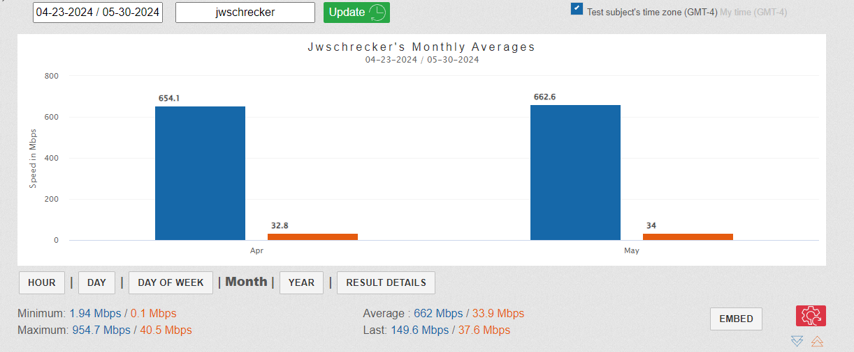
I have made every effort to work with Charter Communications DBA Spectrum to resolve these issues so I may receive the service that I’m paying for (1 Gb). I have waited the requested time advised by Perez (1 week to 1 month; see contact entry Tue 04/23/2024 from 8:00 AM-9:00 AM) for improvements to be made to my service. By my calculations this deadline was reached Thursday May 23, 2024. As of May 29, 2024, I’ve seen no improvement in my service. As of May 30, 2024 I’m still experiencing intermittent internet disconnects, inconsistent internet speeds, internet speeds far below (typically 34.4% less) than the 1000 Mbps service I pay for.
ICM Disconnection Data [intermittent] collected since 04/21/2024 (after reformatting and reinstalling fresh OS on my personal computer to eliminate it as a factor).
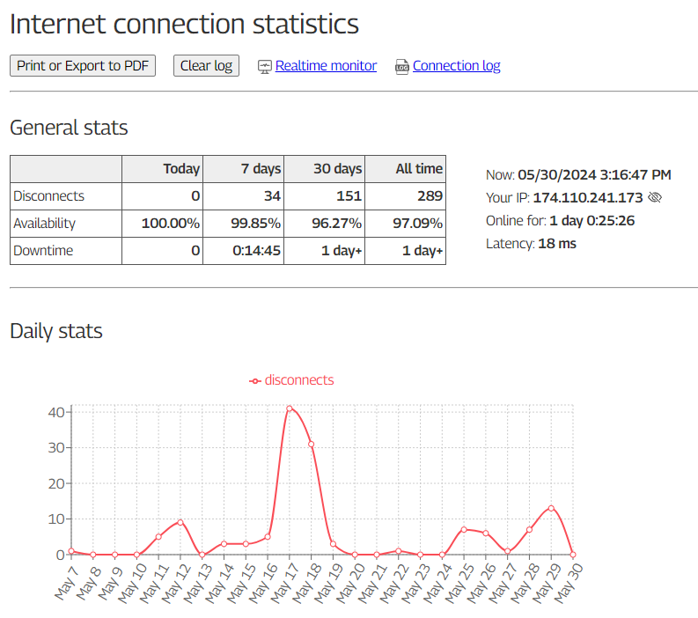
I am extremely disappointed with the poor quality of internet service provided by Spectrum, as evidenced by the network issues identified during ICM, TestMy.net and PingPlotter diagnostics in conjunction with the complaints of the surrounding neighbors. The severe packet loss, elevated latency, signs of a saturated pipe and weather related issues and numerous intermittent disconnections clearly demonstrate systemic problems within Spectrum's network infrastructure, severely impacting the reliability and performance of the internet service for myself and other Eastover (Tranquil Acres) residents.
It may prove very informative to inquire as to the number of subscribers connected to the node that serves Tranquil Acres. Has Charter Communications DBA Spectrum included too many subscribers in the same service group and provided too few channels for such subscribes, thus causing an Internet “traffic jam” (particularly during peak hours) that slowed every subscriber’s connection to speeds substantially below what was promised (see Appendix 8 [Product Details] [Broadband Facts]) and paid-for?
What is the age of the node that serves Tranquil Acres? Electronics are electronics; if a typical cable modem can degrade in approximately three to seven years then what about nodes? The age of the lines servicing Tranquil Acres would be important to know too. When was the last time that Charter Communications DBA Spectrum tested for, located and repaired any rain water leaks into this area of the infrastructure?
Is Spectrum throttling customer speeds to mitigate and hide infrastructure problems such as numerous sporadic disconnects due to rain water intrusion and aged out components incapable of handling the extra demand of ‘typical’ 500 Mbps and 1 Gb Mbps service in the Tranquil Acres area?
I respectfully request that you investigate this matter thoroughly and take appropriate action against Spectrum to address and resolve the network issues identified (see Appendix 7). I also request Spectrum to improve the quality and reliability of the internet service provided to ensure a seamless and uninterrupted online experience for its customers at the speeds that it advertises, assures the FCC of, and for which it bills its customers (see Appendix 6).
Also, consideration should be given to the age of Spectrum’s equipment (cable, nodes, etc) in the Tranquil Acres (Eastover) area. What may have been sufficient cabling in the 1970 cable television era prior to the internet may be the problem today.
I’m also suspecting that Spectrum has throttled my (and others) internet speed in an attempt to mitigate the numerous internet disconnections we’ve been experiencing. Quite obviously, this would be unethical since I’m paying for 1 Gb speed and should be receiving at least 990 Mbps consistently (typically) according to their own employees and their Broadband Facts reported to the FCC (see Appendix 1).
Furthermore, I respectfully request that these resolutions to the problems being experienced by me and the other residents of Tranquil Acres (Eastover, N.C.) are made the top priority by Charter Communications DBA Spectrum and a reasonable deadline (weeks, not months or years) for these resolutions be established with appropriate consequences for non-compliance enforced.
Thank you for your attention to this matter. I look forward to your prompt response and a satisfactory resolution to this issue.


Tools:  - https://internetmon.org  - https://testmy.net  - https://www.pingplotter.com  - Netgear CM 1200 Cable Modem  - My Personal Computer | Sources:  - https://www.spectrum.com/buy/internet?wcmmode=disabled  - https://www.fcc.gov/consumers  - https://www.fcc.gov/broadbandlabels-glossary

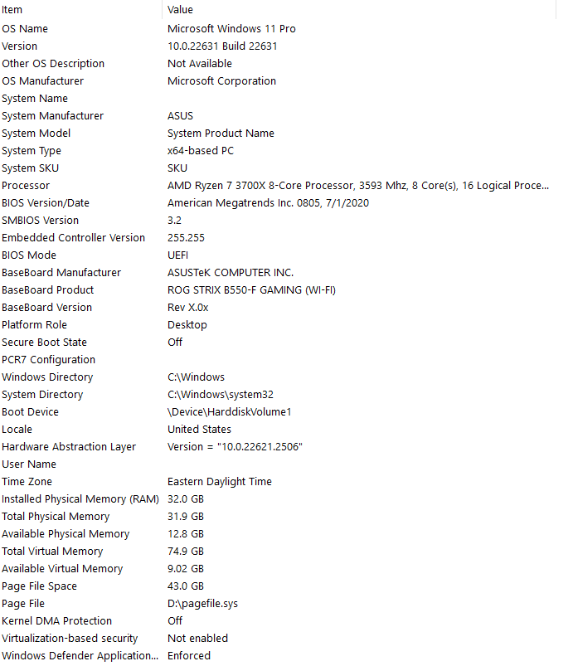

Appendix 1

Ashley Lewis Plan Jerry Schrecker Plan
In Relevant Part In Relevant Part

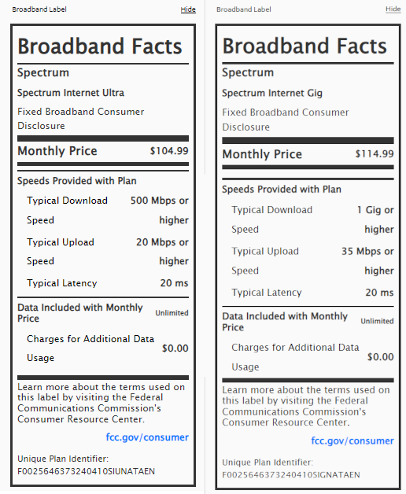
*Typical Download Speed is the speed that data or bits arrive to a device, often measured in Mbps. Higher numbers represent faster speeds. Lower download speeds may impact the quality of video, gaming services, and other applications.

*Typical Upload Speed refers to the speed that data can be sent from a device to other devices, often measured in Mbps. Higher numbers represent faster speeds. Upload speed may affect applications that transmit large amounts of information, or bits, such as photo uploads and video conferencing. Lower upload speeds may make it difficult for multiple people in a household to work remotely or attend online classes at the same time.

*https://www.fcc.gov/broadbandlabels-glossary

Appendix 2
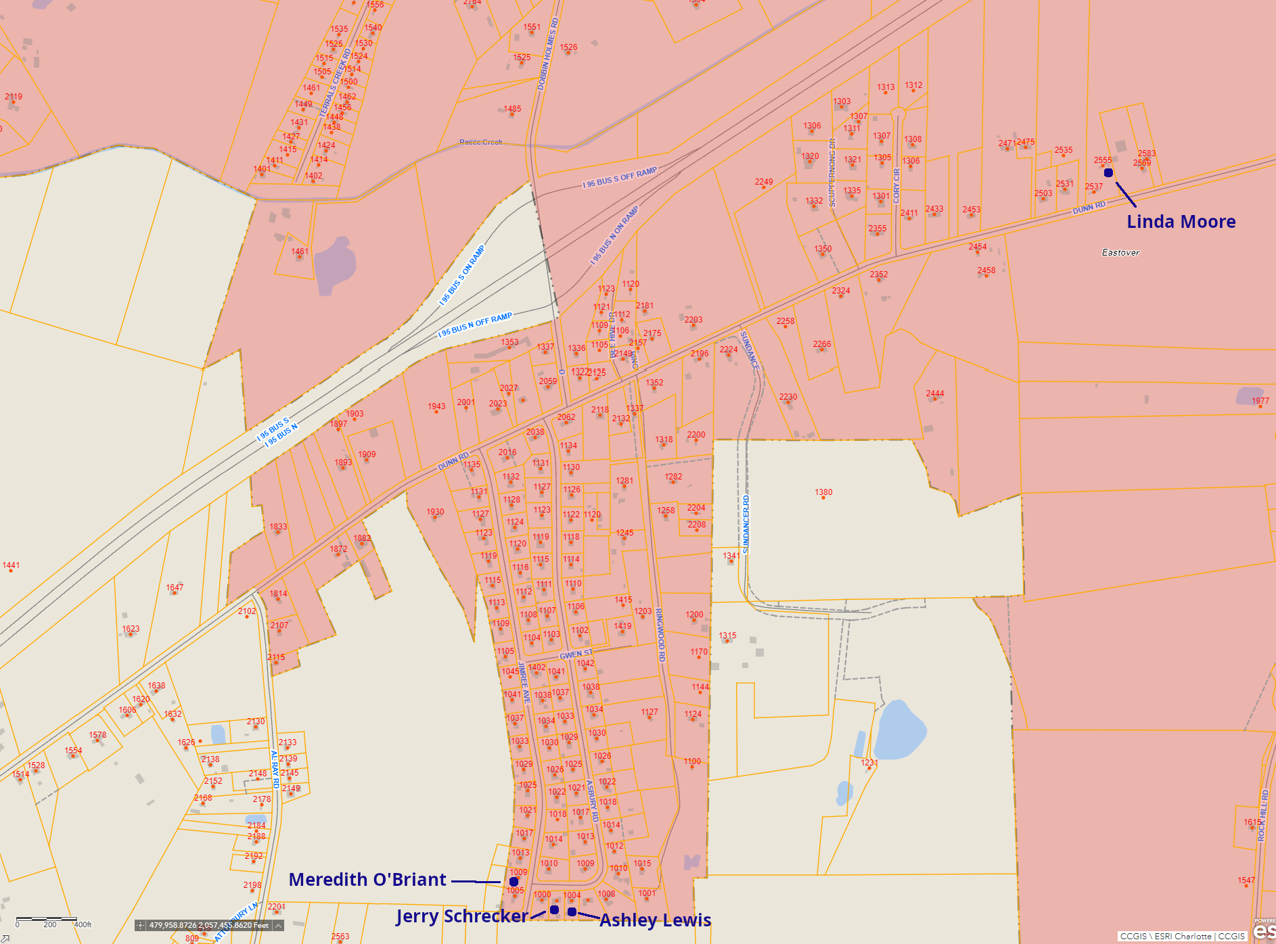

Appendix 3
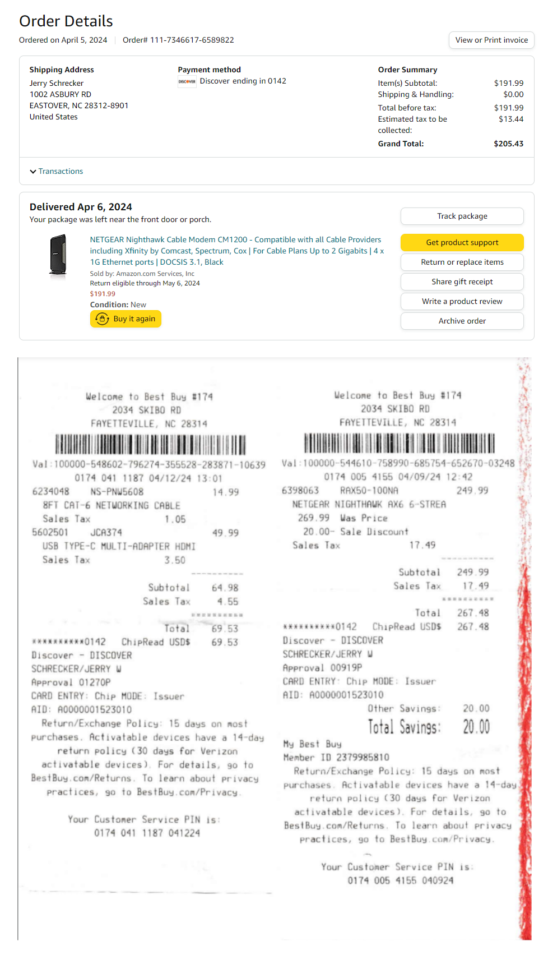
Appendix 4

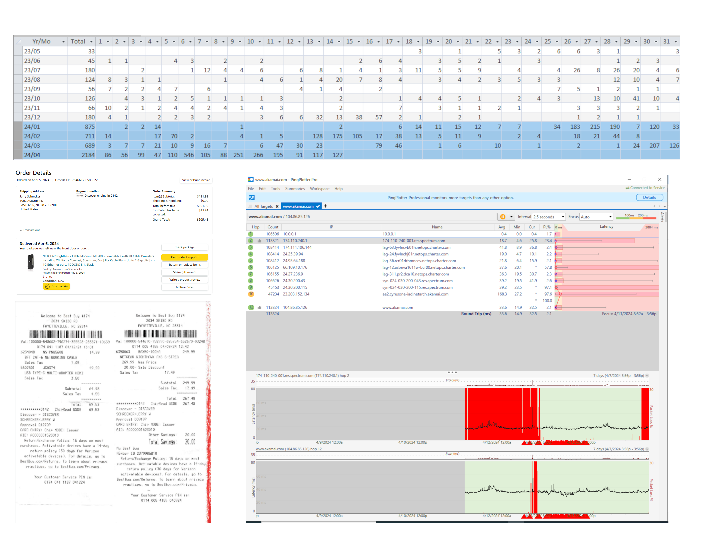

Appendix 5

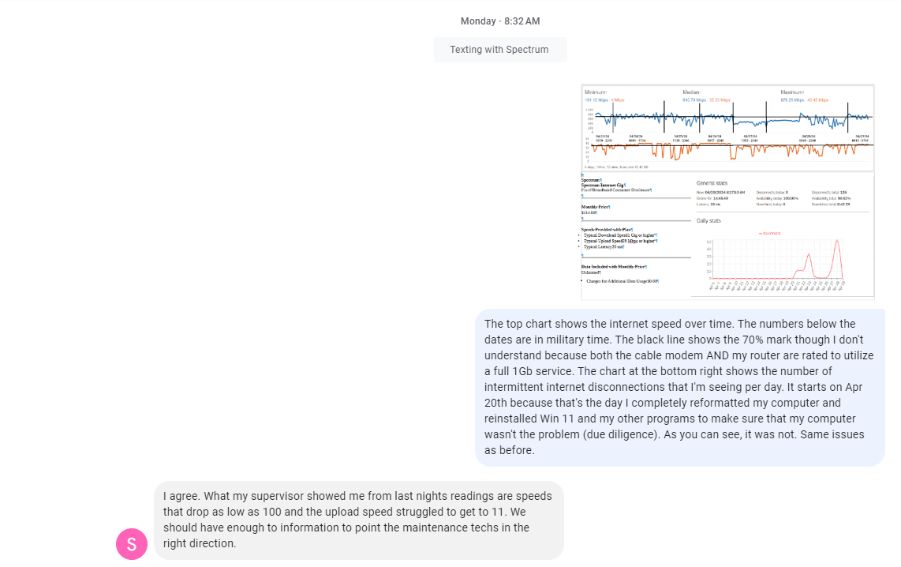

Appendix 6

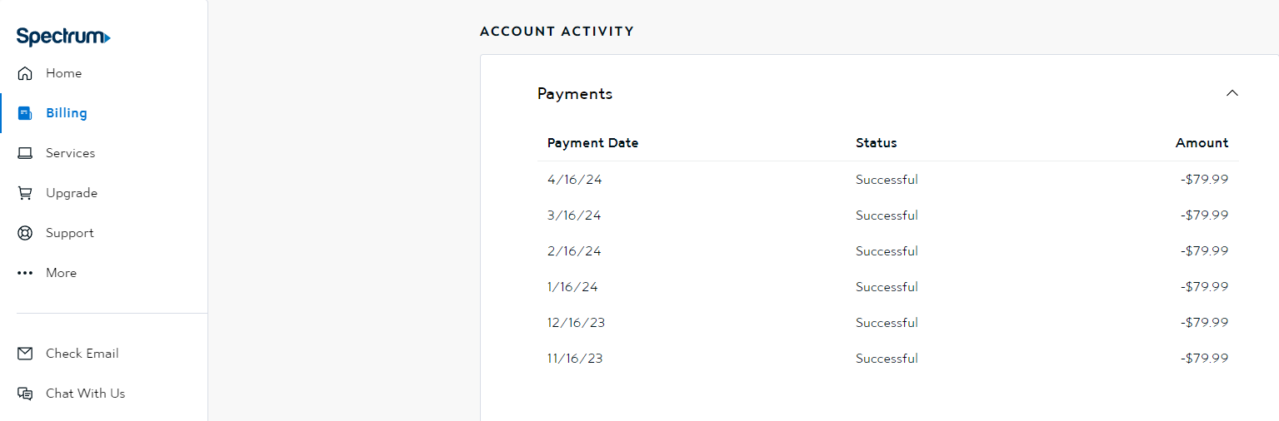
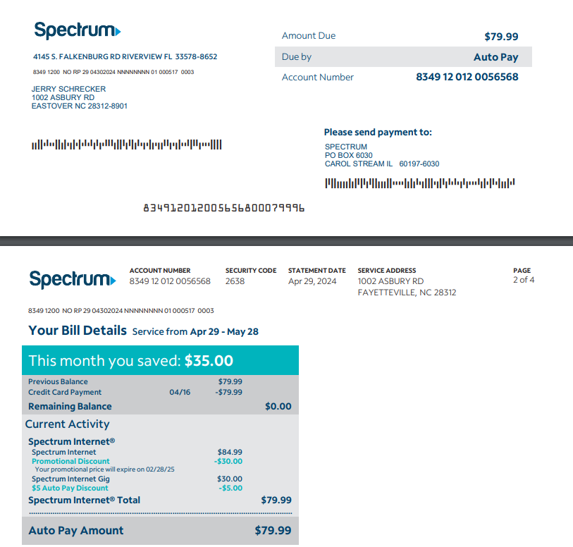

Appendix 7

Thursday May 2, 2024

Notifications to Michael Perez – Spectrum Manager - 1-910-785-1935
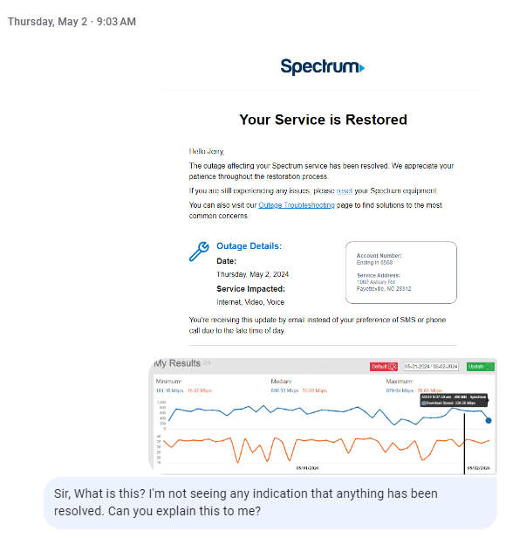

Saturday, May 4, 2024 | Tuesday May 7, 2024
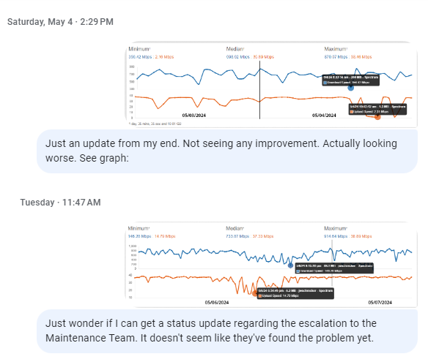

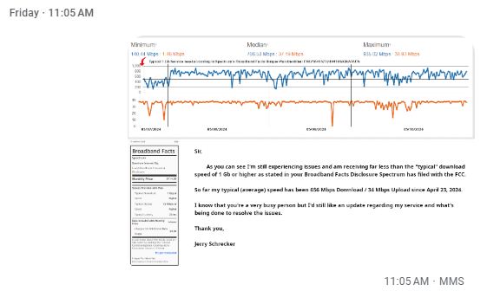
Friday May 10, 2024

Monday May 13, 2024

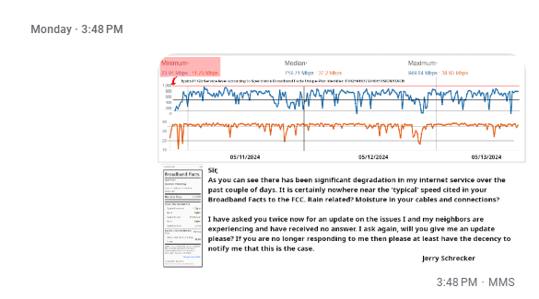

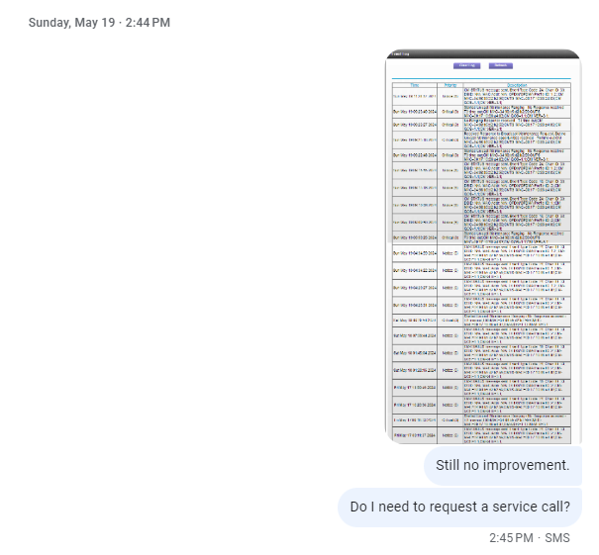
Sunday May 19, 2024
TestMyNet Results
This data has been collected from April 23, 2024 through May 30, 2024.
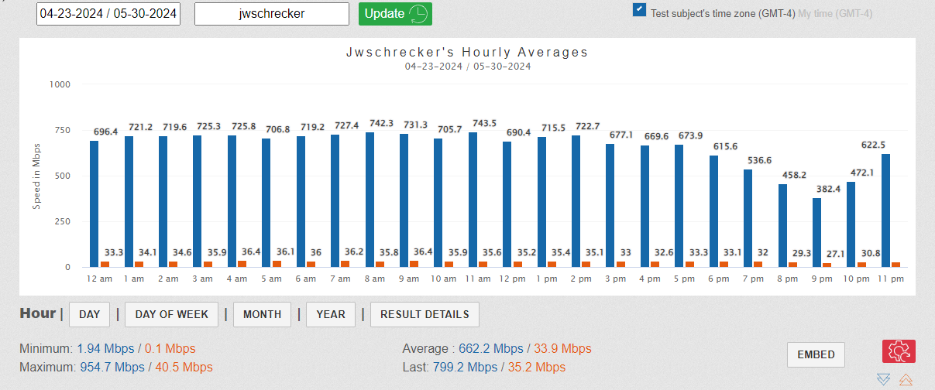
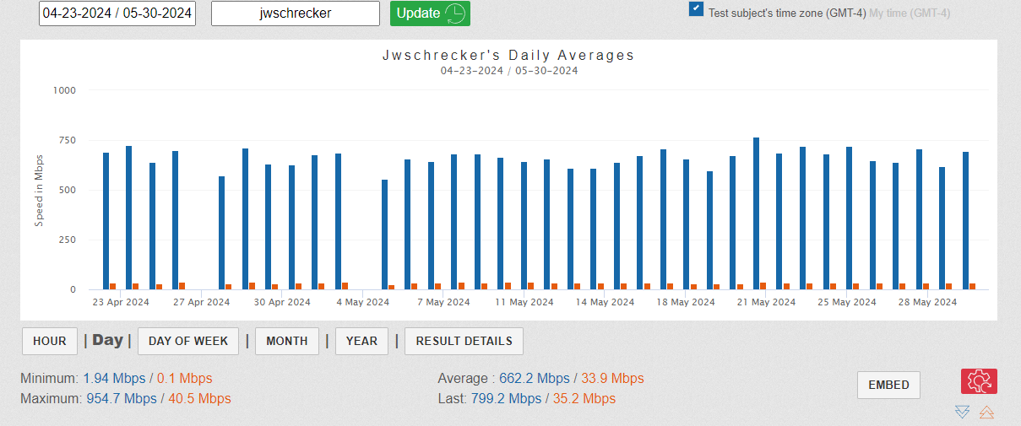
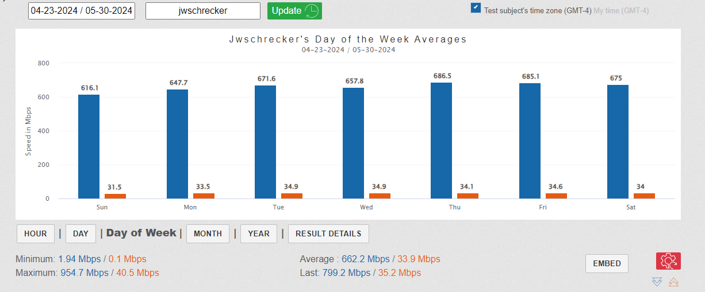

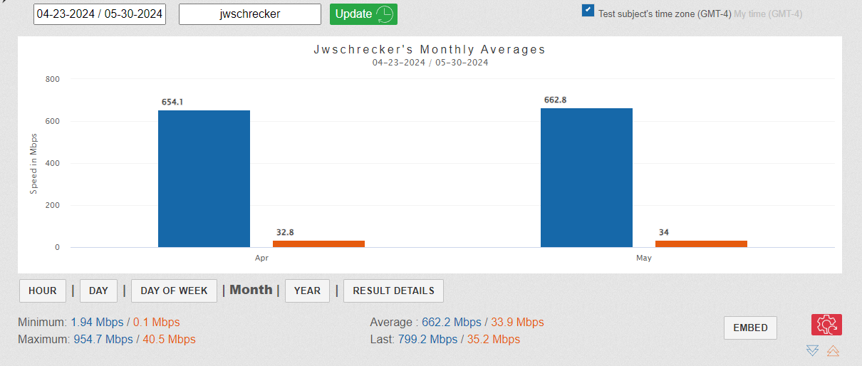
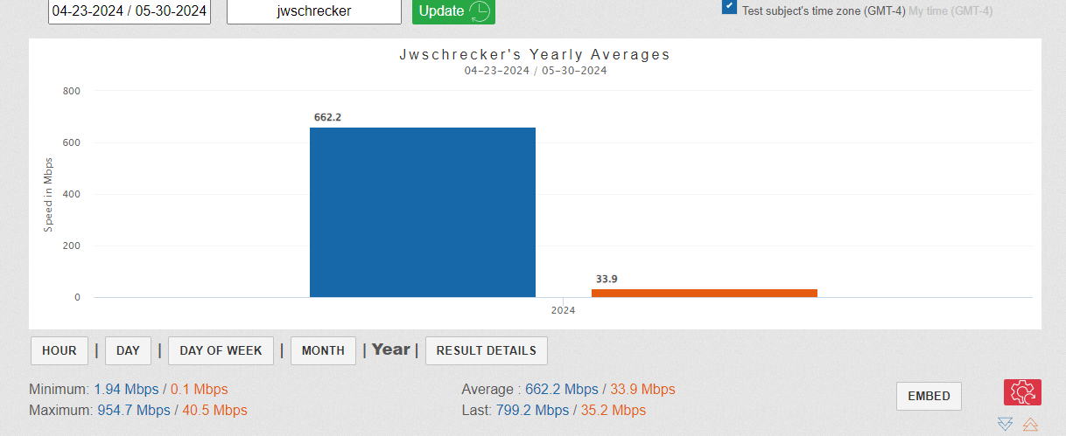

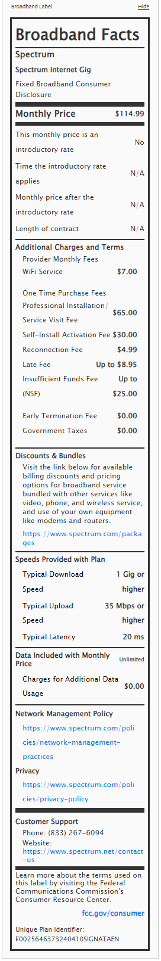
Appendix 8
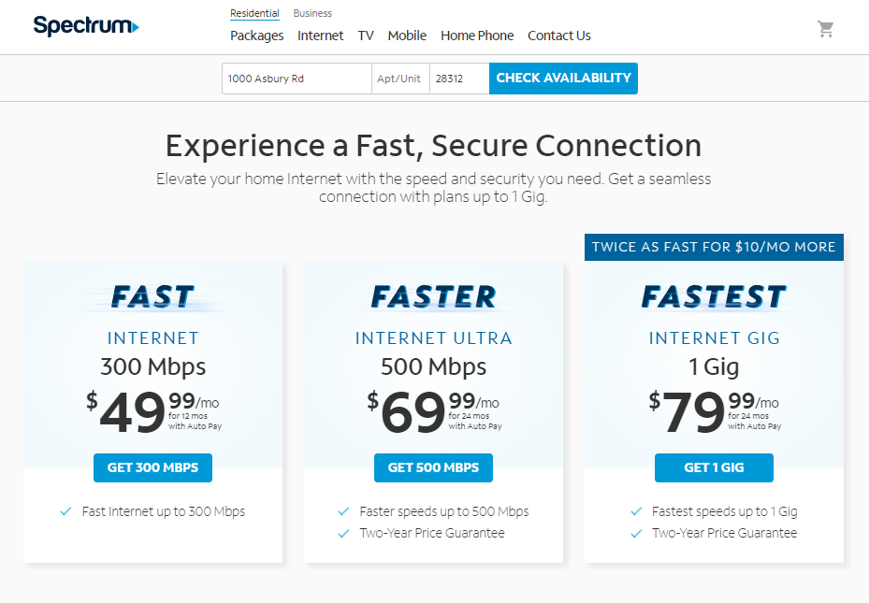
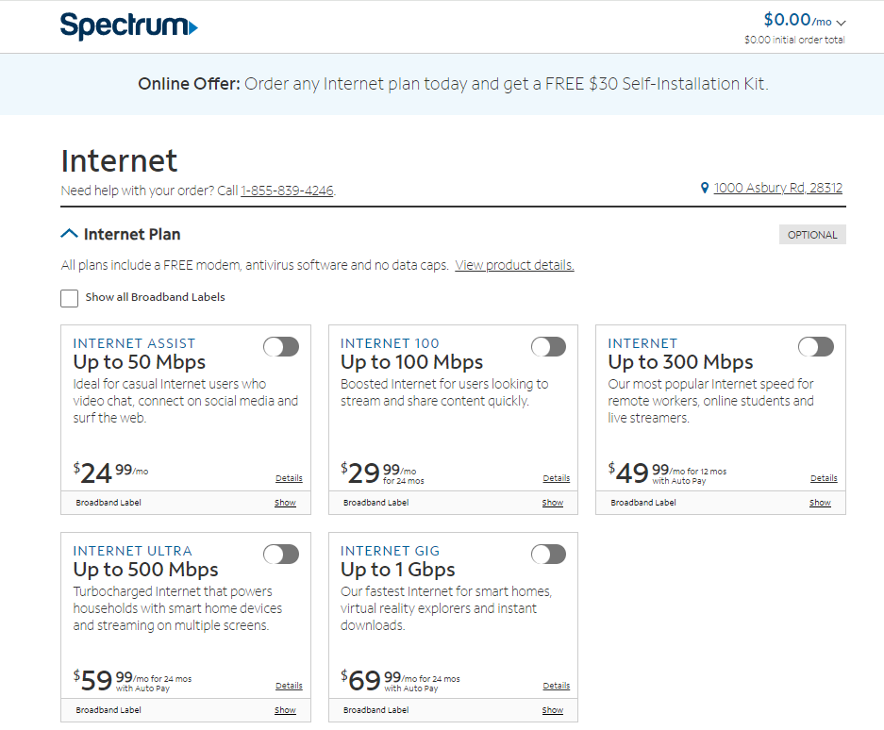
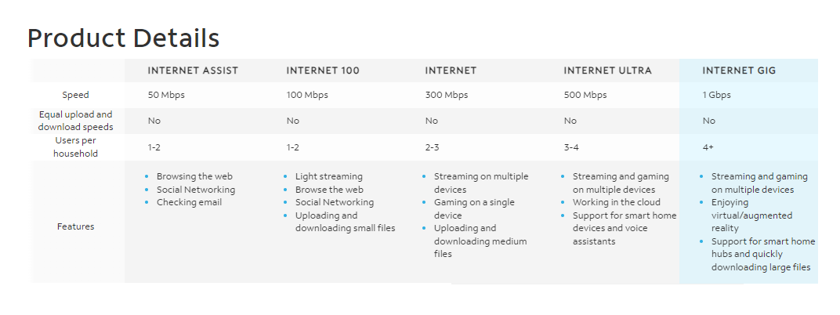
Appendix 9
Customer 9:31 AM [5/16/2024]
<Spectrum> Hello, my name is Kristina and thank you for reaching out to Spectrum. I see you have questions about how to use an internet modem. Please give me a moment to review your information.
<JW Schrecker> How do I access the cable modem diagnostics webpage of the ET2251 cable modem you installed in place of my cable modem?
<Spectrum> Thank you so much for chatting in today. May I confirm to whom I am speaking with today.
<JW Schrecker> Jerry
<Spectrum> Thank you for your question, Jerry. Please elaborate on your question, we don't allow access to the Spectrum modems.
<JW Schrecker> So how do I find out what critical errors and warning are popping up that would affect my service?
<JW Schrecker> *warnings
<Spectrum> Thank you so much for your questions. I am here to assist you if you are having any issues with your services.
<JW Schrecker> I have been for a while. When I had my brand new cable modem in place I could see the critical errors and warnings that were happening. When you all replaced my brand new modem with yours I could not see what's happening anymore.
<Spectrum> Thank you for bringing this to our attention. Jerry, if I can have one moment I will access your account and we can work on this for you. Are you currently home and available to troubleshoot with me further?
<JW Schrecker> Yes, I'm at home and if you read the account notes you'll see that I've been through all the steps that you're about to suggest several times and my problem has supposedly been escalated up to the Maintenance Team. So far, there's been no improvement in the service. I want to see for myself what critical errors and warnings are being thrown by the cable modem. How do I acquire this data?
<Spectrum> Thank you for your explanation. I do see there has been some maintenance done. Access to the Spectrum modem is not an option. I am sorry for the inconvenience.
<JW Schrecker> Since YOUR modem has solved nothing and put a roadblock in my way, how do I get MY modem back in service and get you to take your modem back?
<Spectrum> Thank you, Jerry for your question. We have a list of approved modems on spectrum.net/authorizedmodems. If your modem is on the list we can reactivate for you and you can drop the Spectrum modem off at any Spectrum store or UPS store.
<JW Schrecker> What number do I call after I switch out cable modems?
<Spectrum> Great question! We can be reached at 888-369-2408 or you can chat back. If you have access to the modem I can assist you with reactivating if you would like.
<JW Schrecker> Ummmmm,.... just how would I be able to continue this chat via an unactivated modem?
<Spectrum> Great question! If I can have the CMMAC address on the back of the modem, I can activate the modem for you; as long as it is on the approved modem list. Would that be okay?
<JW Schrecker> New Modem: 3498B5D2B259
<JW Schrecker> Netgear Nighthawk CM 1200
<Spectrum> Thank you so much!
<Spectrum> Thank you and great news! The modem is on the list and I can make the change for you. I will need to authenticate the account. May I have the security code on the account please?
<JW Schrecker> Where would I find that?
<Spectrum> Great question! If you have a bill handy, it will be located in the top-left corner of your billing statement.
<JW Schrecker> I autopay. I don't get a bill.
<Spectrum> Thank you for working with me today. I can send you a one time code via text or email. Which would you prefer?
<JW Schrecker> 910-309-9928
<Spectrum> Thank you, Jerry. I will send a code to the phone number on file. Please respond with the code once you receive it.
<JW Schrecker> 598916
<Spectrum> Thank you! This will take me a few moments.
<JW Schrecker> Let me know when I need to switch out the cable modems please.
<Spectrum> Of course! One moment please.
NOTE: She did not tell me when to switch out modems because she cut herself off when she activated my personal cable modem and I was still on the Spectrum modem. I had tried to warn her. I connected my Netgear modem and had to call in on the phone for it to be activated again anyway. Just another example of Charter Communications DBA Spectrum’s ill trained employees (chatbot?) that cause customers to experience poor service.
Appendix 10
The terms "internet" and "intranet" refer to different types of networks, each with distinct purposes and characteristics.
- Internet
  - Definition: The internet is a global network of interconnected computers and servers that communicate using standardized protocols (TCP/IP).
  - Accessibility: Publicly accessible to anyone with an internet connection.
  - Scope: Vast and worldwide, connecting millions of private, public, academic, business, and government networks.
  - Purpose: Facilitates a wide range of activities, including browsing websites, sending emails, social media, online shopping, and accessing a vast array of online services and information.
  - Examples of Services: World Wide Web (WWW), email, file sharing, streaming services, social networking sites.
  - Security: Generally less secure compared to intranets, requiring robust cybersecurity measures to protect data and privacy.

- Intranet
  - Definition: An intranet is a private network accessible only to an organization's staff. It uses internet technologies (such as web browsers and servers) but operates behind a firewall.
  - Accessibility: Restricted to authorized users within an organization.
  - Scope: Limited to a specific organization or group, providing internal communication and information sharing.
  - Purpose: Supports internal operations, enhances collaboration, shares company resources and information, and improves workflow within the organization.
  - Examples of Services: Internal websites, company directories, document management systems, employee portals, collaboration tools.
  - Security: Generally more secure than the internet due to restricted access and internal controls, often protected by firewalls and other security measures.

- Key Differences
  - Public vs. Private: The internet is public, whereas an intranet is private.
  - Accessibility: Anyone with the appropriate technology can access the internet, but an intranet is accessible only to authorized members of an organization.
  - Scope: The internet spans globally, while an intranet is confined to a single organization.
  - Purpose: The internet provides a platform for global communication and information sharing, whereas an intranet focuses on internal communication and resource sharing within an organization.
  - Security: Intranets typically offer higher security within the organization, while the internet requires extensive security measures to protect against external threats.
  - In summary, while both the internet and intranets use similar technologies, they serve different functions and user bases, with the internet being a public, global network and intranets being private, organization-specific networks.
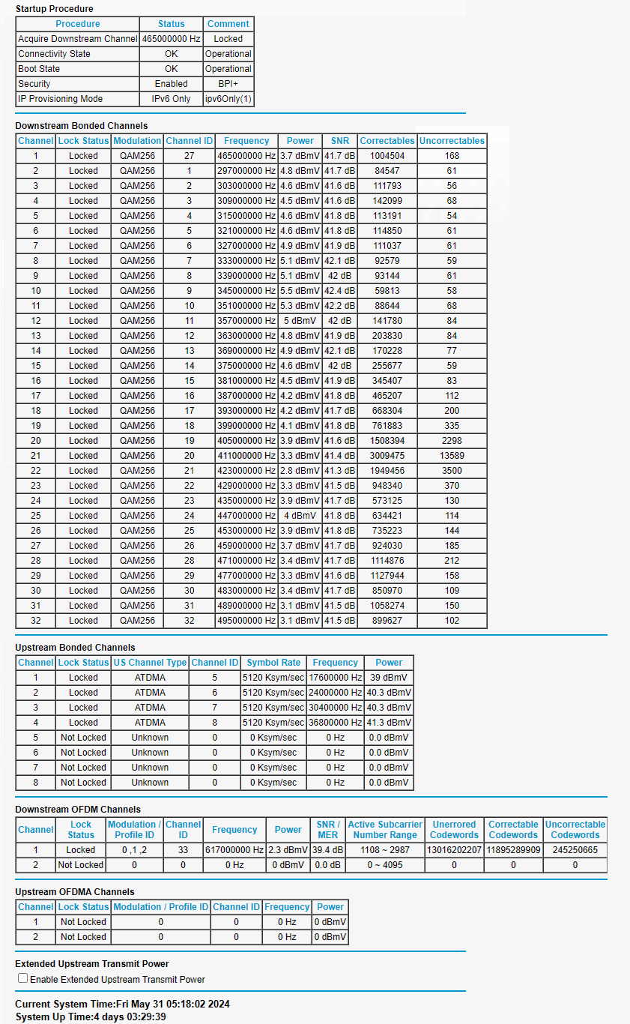
Appendix 11

